Game story

A bad place

english
You wake up in a room, with no memories of where you are and what place you’re at, the environment around you isn’t great. Nobody seems to live here, as if it has been abandoned, your only ally is a malfunctioning IA. You only have one goal in mind, get out of there. By using everything you see in that lab with the help of the AI you must escape.

français
Vous vous réveillez dans une salle, sans aucun souvenir de où vous êtes et ce qu’est cet endroit, l’environnement autour de vous n’a rien de très accueillant. Personne ne semble vivre ici, comme si ce lieu avait été abandonné, votre seul allié est une IA défaillante. Vous n’avez qu'un seul objectif en tête, sortir d’ici. Grâce à l’aide de cette IA et des éléments que vous retrouverez dans ce labo, vous devrez vous échapper.

Location layout

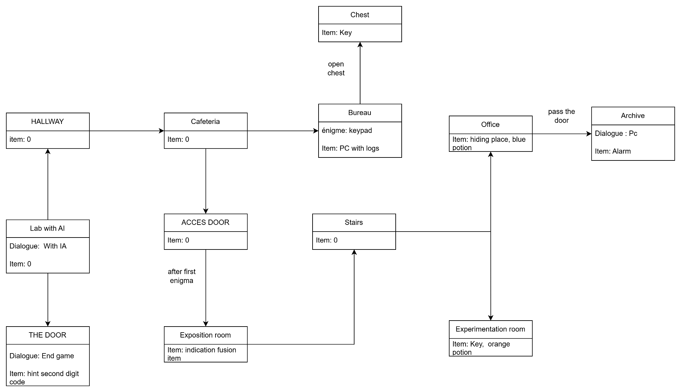

Characters

Main Character
The one you play as

The AI
The players support, give you hints, intel to help you get out

Monster
The entity guarding the place, non hostile but will attack if you cause trouble or try to run away. Don’t get caught

Puzzle structures

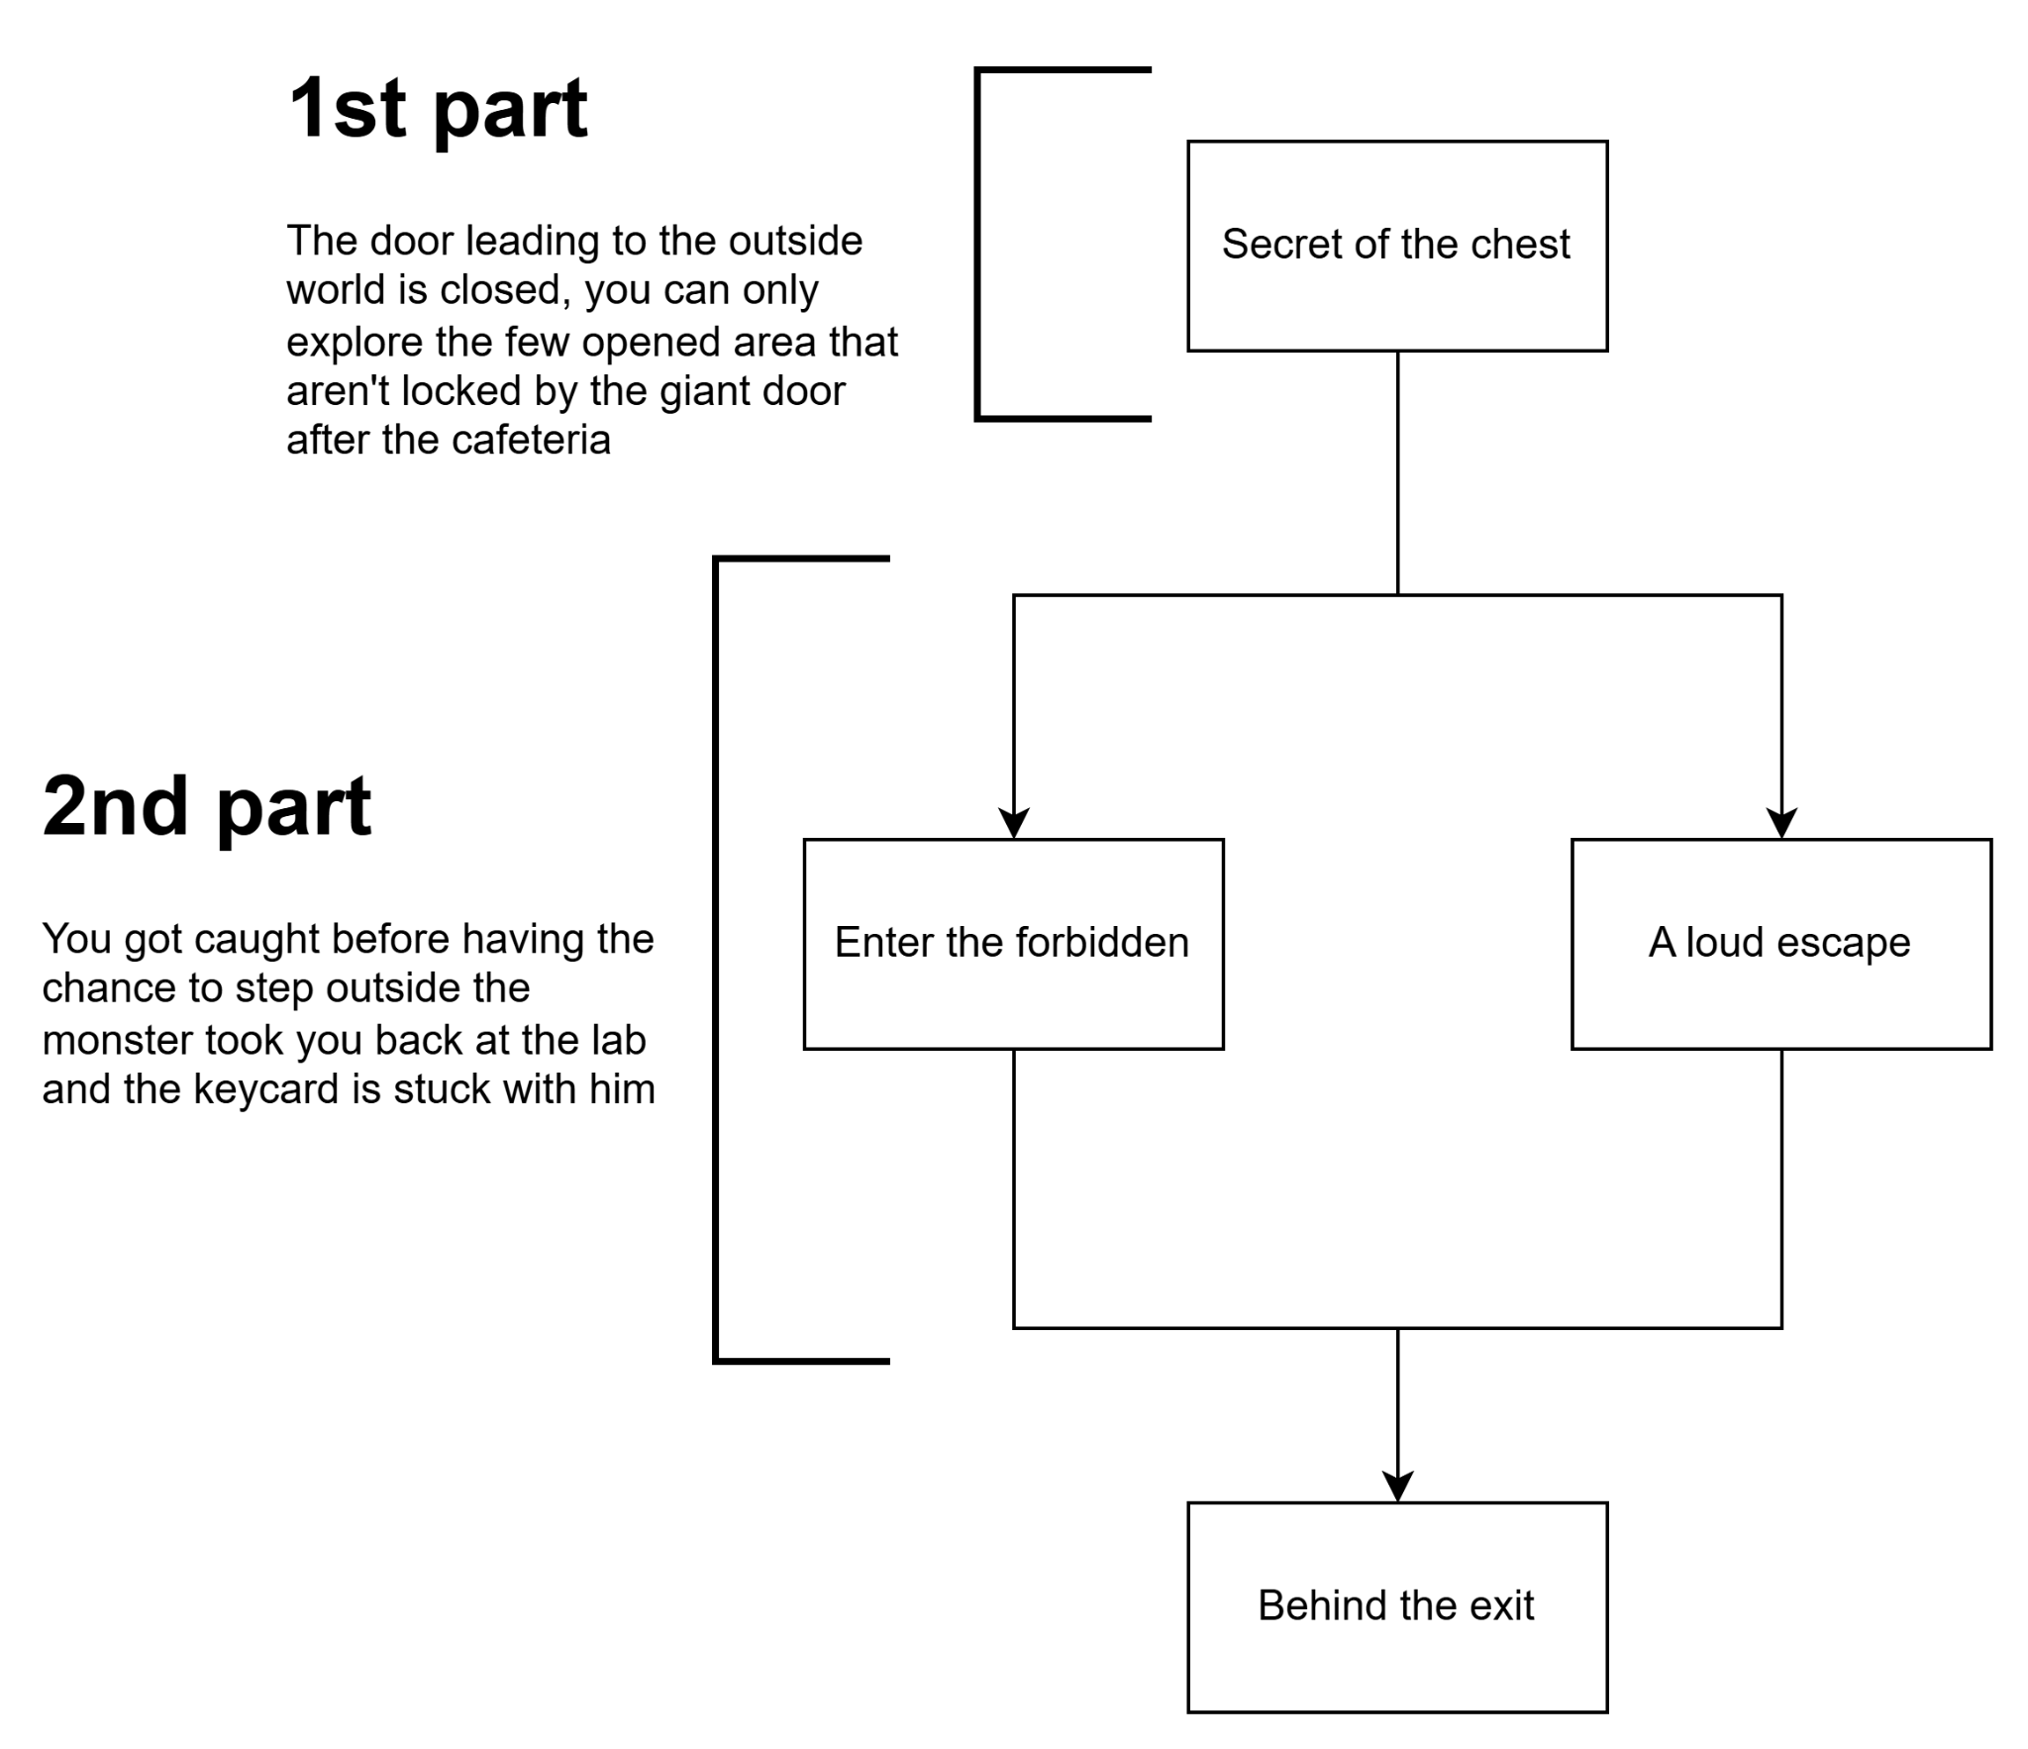

1st enigma (The secret to the chest)

Situation: You enter the office and see a chest, it’s locked, you know there’s something important inside, and the only thing stopping you is a digital code, find the code.

Solution: While looking through the logs on the office’s computer you find some clues about the possible number of the code.
The first one is about how bad the food is in the cafeteria and the writer speaks about his wish to eat at his favorite restaurant, he specifies the number of his favorite menu number 9.

The second one is about some commercial employees visiting the places and leaving a cute AD with a number 0 written on it

In the third one, he’s talking about how depressing the place is and complain about how the only guy he can spend time with is annoying, reading that you can go ask the AI about the author of those notes and he give you some fact about him and the obsession over the number 7

2nd enigma (Enter the forbidden)

Situation: While looking around the new area you find a door locked. It looks impossible to open by normal means you need to open it somehow.

Solution: While exploring the newly opened area you can find flasks, collect them then you’ll be able to fuse them and create a new substance, you can use it on the door and break the system in order to enter the archive

3rd enigma (A loud escape)

Situation: The key is just under your nose and the monster is right there guarding it, you can’t get it with the monster in the same room.

Solution: You ask the AI to find a way to get the key guarded by the monster, it tell you that in the archive there’s something the monster want to keep safe, you break in and find it then you escape from the monster by hiding in the rows of desks, then you’ll be able to get the key

